**DataSaver**https://datasaver.org

Data Saver is a crowd sourced network of public/private wireless (Wi-Fi) networks that are shared globally.

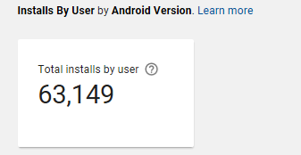The DataSaver app was released on Android over a year ago and has had several updates along the way. Users locate and connect to “shared” Wi-Fi networks in the area by importing a list of networks in their area. The networks and passphrases are imported into the phone/tablet’s memory and when the device is in range it will connect automatically.

The app has grown completely organically and users overall find it great for them and easy to use. See android developers console graphs below.

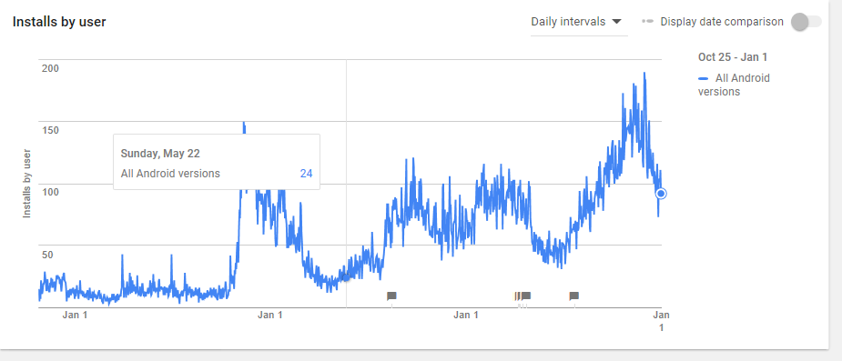

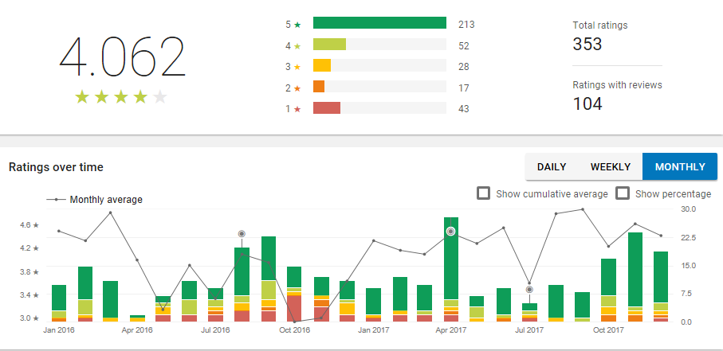

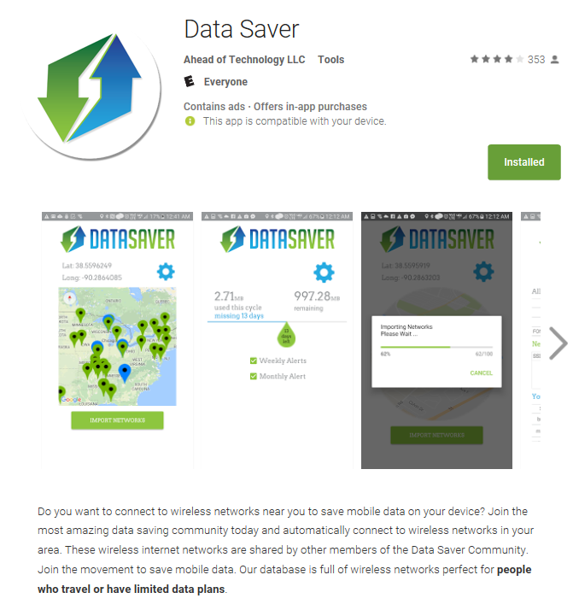

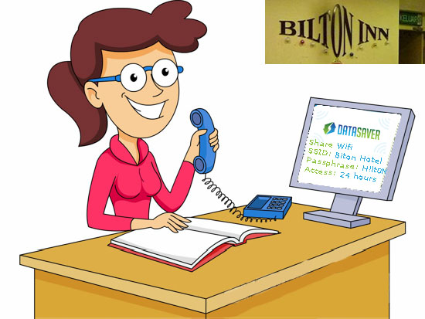

**The Future:**

We are redesigning the Android app, creating an iPhone app as well as applications/wallets for PC, Mac, and Linux. We are also adding blockchain technology to store a public ledger of open/shared wifi networks, encryption type, passphrases, GPS coordinates etc. We will also be adding smart contracts to distribute network info for a certain length of time to one or multiple users. Once the allotted time has expired, the network info is removed from the device and they are disconnected from your secured network.

**Possible promotions:**

We plan to target hotels/hospitality who currently rely on 3rd party companies to host their Wireless/Wired Network landing pages, authentication and payment processing. This would save owners thousands of dollars per year, per property and would take the power away from the 3rd parties and put the ecosystem in the cloud with a distributed peer to peer network.

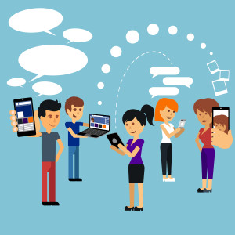**DataSaverCoin(DCS)**

DataSaverCoin will be the currency used on the DataSaver Network.

Coins are used:  
- to reward the network owner for sharing a private network.  
- to pay for enhanced speed.  
- to pay for extended period of time.  
- to pay for data caps if applicable.

**There are Five Types of Coin Holders:**

***Investors:*** Bought coins during the ICO (Initial Coin Offering) or they traded currency for them at a later date.

***Developers:*** The people that created and maintain this platform.

***Clients:*** Users of the platform and network.

***Oracles:*** Contributors of the network. (*must hold x amount of coins and have x amount of points/score)

***Clients/Oracles:*** Most Oracles are also Clients but we consider them Oracles as well (possible future benefits).

**Clients** can import wireless network names, credentials and GPS coordinates [End Nodes] to automatically connect to them once they come into range. Clients can also share their networks to become an Oracle (End Node owner).

Clients can connect to an End Node for free and obtain free access to Internet (up to 14 days per year for free per End Node then the client pays the Fee to the Oracle). The Oracle will receive *20 coins per day per client & *20 coins go to the development team (*40 total) 10% for the Further Development. 5% to their personal wallets & 5% to escrow (future supply).

New clients [generate] get *300 coins for free to use our networks and pay out fees after the 14 day period per network. Then the client will need to obtain more coins to use those networks.

**Oracles** share private networks that require passphrases to simulate ownership. Open networks can be shared as well to help raise the Oracle’s trust level (which also raises their earning reward). Once the End Node (SSID) is shared it will generate *100 coins (earning reward) that will remain pending until a new user connects or tries to share the same SSID (End Node). Once this happens the *100 coins are distributed to the Oracle.

Oracles can recall an SSID / End Node to prevent future down votes. (Only oracles or admin can remove this End Node)

**Ledger:**

All networks that have been submitted/recalled/abandoned are stored publicly on our Blockchain.

The app/wallet will verify current valid networks and import them directly to your device as if you have connected to this network before. On the contrary it will also verify if End Nodes are still active in an area that it was before. If not it will down vote the End Node which also effect the Oracles Trust Level.

**End Node Scores:**

|  |  |  |
| --- | --- | --- |
| Score (positive events) | Grade | Ratio negative/positive votes |
| 91%-100% | ***** | 1:10 |
| 81%-90% | **** | 2:10 |
| 71%-80% | *** | 3:10 |
| 61%-70% | ** | 4:10 |
| 51%-60% | * | 5:10 |
| 0%-50% | Abandoned | 6+:10 |

**Trust Level:**

Oracles are ranked on their **Trust Level** which is calculated by the number of End Nodes (networks) they share, their End Node (networks) scores, and current status.

|  |  |  |
| --- | --- | --- |
| Score (positive events) | Grade | Ratio negative/positive votes |
| 91%-100% | ***** | 1:10 |
| 81%-90% | **** | 2:10 |
| 71%-80% | *** | 3:10 |
| 61%-70% | ** | 4:10 |
| 51%-60% | * | 5:10 |
| 0%-50% | Abandoned | 6+:10 |

Coins are generated when oracles are created, End Nodes are verified, coins that are pending for x amount of time are either burned/destroyed or given to something, most likely destroyed will help with inflation/deflation.

**Wallets/Apps**

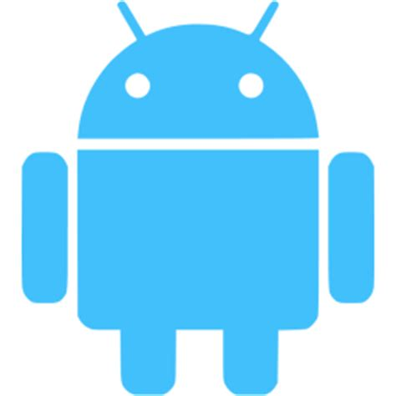  
Windows Android iPhone Mac OS Linux

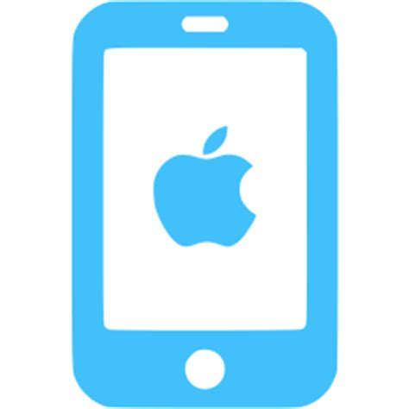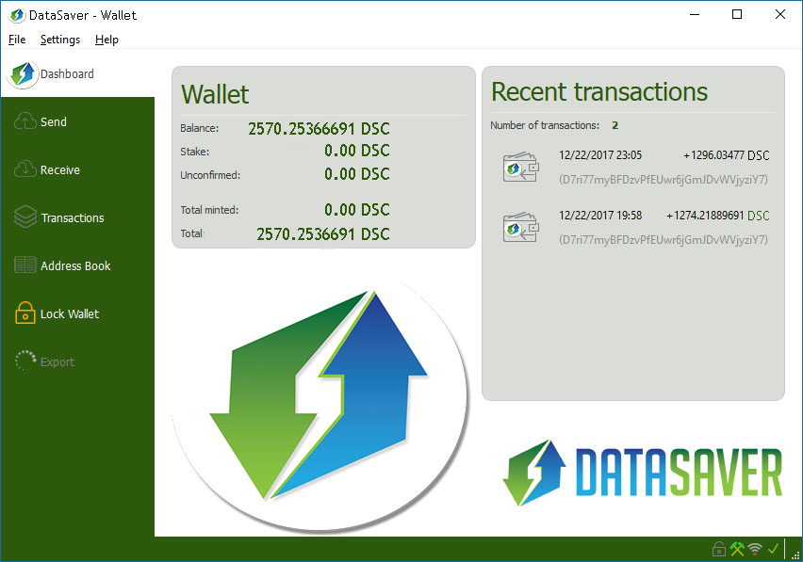

**Branding/Promotions**

